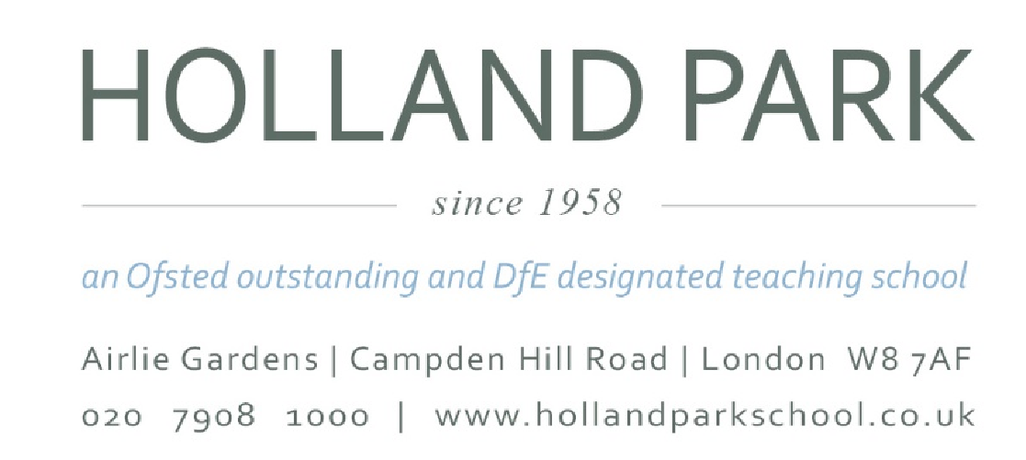

23rd May 2022

Dear Parents and Carers,

I write to you today to confirm that, sadly, there is due to be further industrial action this week at Holland Park School.

This follows a ballot of staff organised by the National Education Union (NEU) which was passed in favour of industrial action, and will see the school closed on Tuesday 24th May and Wednesday 25th May for all students except those taking exams.

We remain in dialogue with the NEU and hope they will agree to call off the strikes. Should that happen, then the school will be open as normal and we will of course let you know as soon as possible.

As well as the meetings arranged as part of the stakeholder engagement process, and the opportunity for all parents to have phone calls with governors, members of the Governing Body are also due to meet with any members of staff who would like to speak with them, either in groups or individually, on Friday this week. We are fortunate to have such an excellent and dedicated staff team, and we understand they would much rather be in the school than on the picket line, particularly during the exams period.

Yours faithfully,

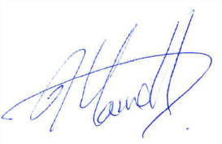
Jane Farrell
Chair of Governors
Holland Park School

